Pre-Reading

What do you want?
The first character in this reading that you may not recognize is 干 (gan4) which here means “to do” it is very similar to the character 做 (zuo4), which also means “to do,” the difference is that 做 can also mean to make where as 干 is usually used just for to do. 干 is also used in sentences like 你在干嘛? (ni3zai4gan4ma?) Which means “What are you doing?” but be careful because 你干嘛(ni3gan4ma?) can be a bit aggressive. The next word 得 (de) is a particle word making 坏事儿(huai4shi4er) an adverb. So here 干得坏事 means “the evil things he did.” 坏 can be thought of as bad or evil, you will see it with 坏蛋 (huai4dan4) which literally means bad egg and is often used to tease friends. 事 simply means things, but things that you have to do, where as 东西are things, as in objects. The next word you will need to know is 相信 (xiang1xin4), the first character 相 means “reciprocal or mutual.” The second character is 信，it is divided into two radicals, the left side is a person and the right side is word, so together the idea is that a person’s word is to be believed. So this character means to believe or trust, the word 相信 also means trust or believe. The next word is 谁 (shei2) is simply who. So you could say “谁打我” which is “who hit me?” Following this character you will see the character 会 (hui4), which means can, or able to. 会 should be compared with 能 (neng2), both mean “can,” but 会 is usually used to signify that you are good at something, where as 能 usually means you have the physical capability of doing something. For example, you can say 我会打篮球, which is “I can play basketball,” but this means I am good at basketball, if you use 能 here you simply mean that you have legs and arms and the physical capability of playing. The next key point is a set phrase: 要是 (yao4shi4) 。。的话(dehua4), this phrase is used to express “if.” So if I say “要是我的话,”it means “if it were me.” The next phrase is 想要(xiang3yao4), is a formal way to say “I want.” So you could say “我想要一个桌子” which means “I want a desk.” The next word is very useful for a classroom, it is 比如 (bi3ru2), which can translate to “for example.” Here, the writer’s sister is going to give a list of things, that she should buy, she uses the word 或者 (huo4zhe3), which means “or.” You can compare 或者 to 还是 (hai2shi), the only difference is that 还是 is used for questions such as “你想要Apples还是Bananas? In this sentence 或者cannot be used. The writer’s sister, says she wants a 电脑 (dian4nao3), a 手机 (shou3ji1) and a 车 (che1). Pay attention to the classifiers and the adjectives. The first one she wants is a 新的电脑. The 电脑 is made of two characters the first is a 电 which means electric, and the second 脑which means brain, so electric brain is computer. The adjective here is 新 which means new, but the 的is needed to give the possession of 新 to the 电脑. 手机 has no adjective and literally translates to hand machine, which means cell phone. Finally, 车 means car, but is described with 非常快(fei1chang2kaui4), which means very fast.
Story Character Count = 63
Vocabulary/Writing

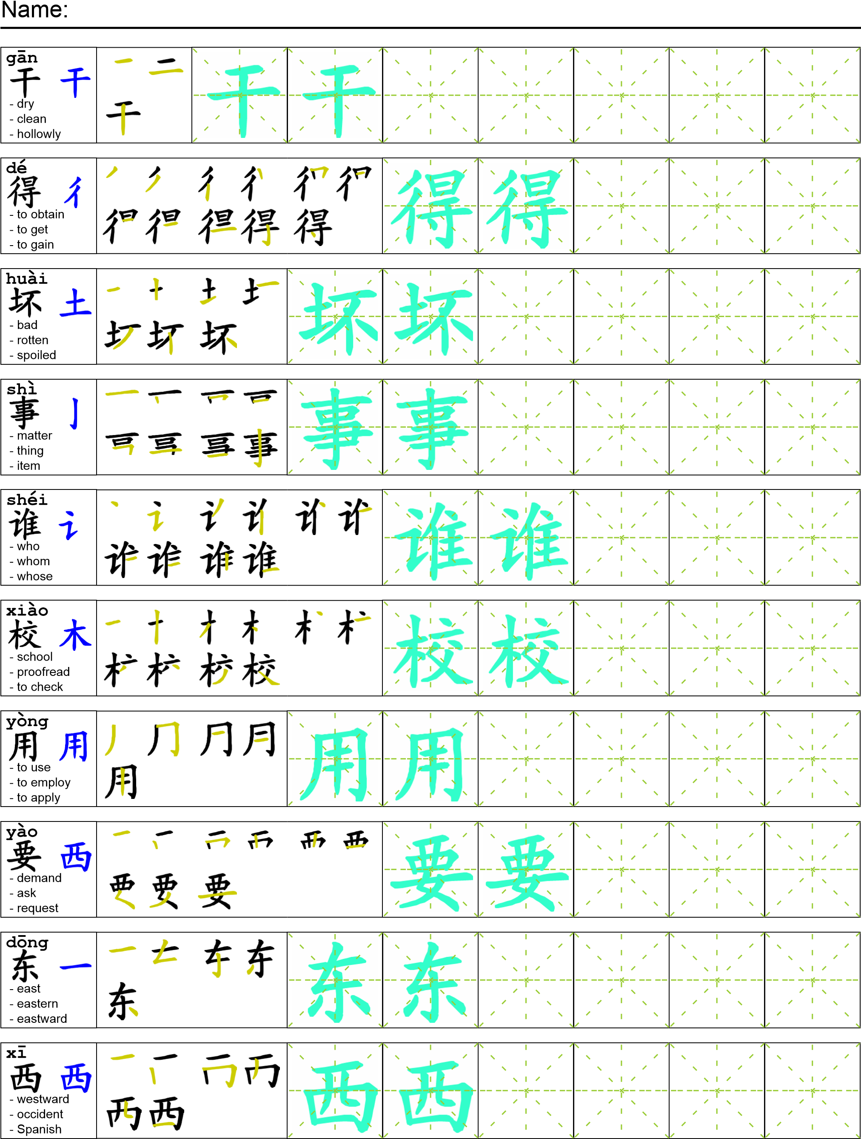
Reading

我告诉我妹妹我爸爸干地坏事。我妹妹不相信。她说：“谁会偷学校用品，要是我的话我就偷我想要的东西。比如新的电脑或者一个手机或者一辆非常快的车。”
Task Completion

Once all tasks are complete turn the assignment in to collect the points for the project.
Task 1: Trace the vocabulary and copy the text into your notebook.

Task 2: Answer Comprehension Questions.

Task 3: Write the Pinyin for the Reading.

Task 4: Translate the Reading into English.

Task 5: Record yourself reading the passage.

Comprehension Questions
- Why can’t the author’s sister believe that their father stole the items?
- What would the author’s sister steal if she could?
- What is the phrase used for “if”?

